**PRE-REQISITES**

**IOT Watson Platform & IOT devices**

|  |  |
| --- | --- |
| DATE | 16 Nov 2022 |
| TEAM ID | PNT2022TMID15102 |
| PROJECT NAME | Real-Time River Water Quality  Monitoring and Control system |
| Marks | 2 Marks |

**IOT Watson Platform:**

* Integrate Continuous Testing Across All Development Stages in the Process with Watson IoT.

* Improve Product Quality through Continuous Testing to Find Issues at the Early
* Stage.

* Optimise Performance. Get Started for Free. Insightful Solutions. Reduce Costs & Hurdles.

**IOT Watson Platform and IOT device with bluemix simulator:**

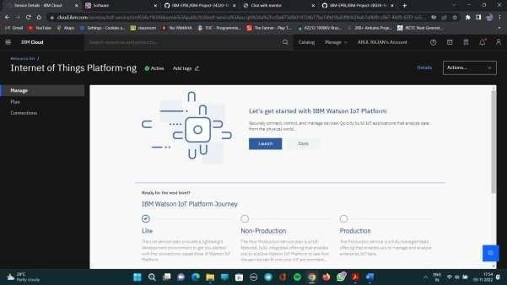

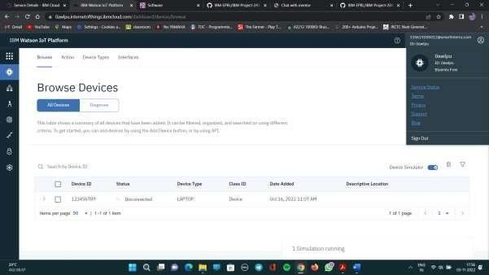

**Device simulation is functional:**

